**Design Thinking Project Workbook**

**Don't find customers for your product but find products for your customers**

**1. Team**

**Team Name:**

**Team Logo (if any):**

**Team Members:**

1. Shaik.Hanifa-2320040009, (Software Developer & Data Engineer)
2. M.Pavani-2320040085, (Project Coordinator)
3. M.Uma Mahesh-23200400135, (Algorithm Developer)

**2. Problem/Opportunity Domain**

**Domain of Interest:**

Predicting Cardiovascular Risk with a Machine Learning Framework

The use of machine learning is studied to predict the risk of cardiovascular diseases in the region of interest by the patient information. This method is such that it tries to achieve accurate models for the early detection of problems and personalized care by bringing together medical knowledge with advanced data analysis.

**Description of the Domain**:

The domain concerns applying machine learning in order to analyze patient data for an enhanced prediction of cardiovascular disease risk. In terms of age, lifestyle, medical history, and clinical measurements, the aim is to look for accurate models that present themselves in early detection and guide procedures for improving prevention and management of heart disease**.**

**Why did you choose this domain?**

I selected this course because cardiovascular disease is one of the most significant killers in the world, and early know-how would significantly improve patient results. Applying machine learning could allow possible opportunity to build evidence-based accurate models and helps to profile those high-risk people so that they receive prompt interventions and proper treatment in their proper time. This can ensure the saving of lives, cutting down on healthcare costs and adopting an approach for heart health care which could be more proactive.

**3. Problem/Opportunity Statement**

**Problem Statement:**

Cardiovascular disease is one of the main causes of death but in the traditional model, often diagnosed after the train has left the station. Traditional risk assessments are not very effective at predicting high-risk people. The problem is to develop a machine learning model that can predict cardiovascular risk and intervene beforehand, thereby reducing the negative impact on the disease.

**Problem Description:**

Its early diagnosis is difficult and even forms a high percentage of deaths when the diagnosis comes too late for the patient. Conventional risk assessment methods lack the perceptiveness to grasp the intricacies of risks. It points towards the use of machine learning algorithms for the analytical processes concerning the patient data for accurate predictions of cardiovascular risks. In this manner, interventions will occur at an early stage and treatments according to the needs of the patients.

**Context (When does the problem occur):**

The issue occurs when conventional approaches are ineffective in evaluating the potential for cardiovascular disease, usually because they struggle to account for the intricate relationships between various risk factors like age, lifestyle, genetics, and medical background. This results in delayed detection, usually when symptoms worsen, decreasing the likelihood of successful intervention. Identifying cases early is very difficult when dealing with people who show no symptoms or have only minor warning signs, so it is crucial to use a data-driven method for predicting risks accurately and promptly.

**Alternatives (What does the customer do to fix the problem):**

To address cardiovascular risk assessment, customers would often rely on standard risk assessment tools like the Framingham Risk Score, health check-ups, and consultation with practitioners according to symptoms and medical history. Besides all that, many choose to have preventive lifestyle changes by general advice and undertaking community health programs. These, however, do not provide the personalized risks.

**Customers (Who has the problem most often):**

The cardinal affected groups include: at-risk patients who can fall into a category such as obesity, diabetes, or a family history of heart disease; the healthcare providers who need these tools effectively to identify high risk; and healthcare systems looking to curb the burden of cardiovascular diseases.

**Emotional Impact (How does the customer feel):**

Many customers are anxious and frustrated with the uncertainty of knowing their own health as conventional assessment procedures might fail to flag potential risks and often do not provide early diagnosis, making them worried about the possible issues in the heart and the effectiveness of the measures that they had used for preventive action.

**Quantifiable Impact (What is the measurable impact):**

The quantifiable consequences of inappropriate cardiovascular risk assessment include over and above healthcare spending, running into millions of dollars in avoidable hospitalizations and treatments, among others, late-stage treatment of heart disease as well as other associated lost productivity from illness.

**Alternative Shortcomings (What are the disadvantages of the alternatives):**

Current solutions, from routine screenings to standardized risk assessment tools and general assessments that are made based on averages of risk factors, are still too general, failing to account for the individual difference within risk factors and resulting in inaccuracies which can be critical enough to cause missed early detection opportunities and ineffective prevention strategies.

**Any Video or Images to showcase the problem: The evidence in the form of video or image).**

**Provide link if available**

**4. Addressing SDGs**

**Relevant Sustainable Development Goals (SDGs):**

The problem of cardiovascular risk assessment has a direct influence on a number of the Sustainable Development Goals. This is by allowing effective prevention and management of heart disease, engaging to Goal 10 Reduced Inequalities through better risk assessment tailored to enhance access to proper healthcare for vulnerable populations, and supports Goal 9 Industry, Innovation, and Infrastructure by fueling innovation in health technology, such as machine learning frameworks. This lastly responds to Goal 17: Partnerships for the Goals, ensuring collaboration among healthcare providers, researchers, and developers of technology to improve cardiovascular health outcomes.

**How does your problem/opportunity address these SDGs?:**

Improving risk prediction for cardiovascular disease using machine learning may change the fortune of most of the SDGs. The speed and in-time correction of the errors in predicting risks will mean faster health interventions, with people earlier receiving the interventions and improved health outcomes along with fewer deaths due to heart diseases, thereby achieving Goal 3: Good Health and Well-Being. Better risk assessment tools also can help to reduce healthcare disparities (Goal 10) through more targeted care and resources to the most vulnerable populations. New technologies being used to full potential also can aid Goal 9: Industry, Innovation, and Infrastructure, making progress toward health-related solutions. Ultimately, collaboration in health care to create these resources fosters Goal 17: Partnerships for the Goals, leading to a comprehensive approach of improving cardiovascular health over time.

**5. Stakeholders**

Answer these below questions to understand the stakeholder related to your project

1. **Who are the key stakeholders involved in or affected by this project?**

Early in the disease, heart detection is very beneficial to patients.

Healthcare Providers- Make use of the system for establishing a diagnosis and cure of the patient .

Medical Institutions: Use the format to improve care.

Data scientists will create and update the predictive models.

1. **What roles do the stakeholders play in the success of the innovation?**

Patient benefits from early detection; provides response.

Healthcare Professionals: Their forecasts can be used in guiding care for the patients.

Medical institutions implement and integrate the system into clinical workflows.

Data Scientists: Building and updating accurate predictive models.

Regulatory bodies assure both safety and conformity with requirements for approval.

1. **What are the main interests and concerns of each stakeholder?**

Patients:

Area of interest: Proper risk estimation, customized care.

Concerns: Data is private, predictability of the result.

Healthcare Providers:

Area of interest: Increased accuracy in diagnosis tools, effects for the patients.

Concerns: What is it going to do to practice, predictability of the result.

Medical Institutions:

Area of interest: Improved patient care with minimum utilization of resources.

Concerns: Cost increased, regulatory concerns.

1. **How much influence does each stakeholder have on the outcome of the project?**

Patients: Neutral influence, adoption, and feedback are moderately influenced by usage. Healthcare Providers: Very influential it is quite important that they agree to the plan. Medical establishments: High level of influence; they have resources and integration power. Data Scientists: Very high. Such experts decide what models are relevant and correct

1. **What is the level of engagement or support expected from each stakeholder?**

Deep Commitment or Accommodation:

Patients: Are expected to have an interest through feedback and an active participation in trials.

Care Providers: Requires extensive education and consolidation.

Resource support and deployment: Active medical institutions.

Continuous work by the data scientists on the development as well as updating of the models.

Regulatory bodies: Involvement in the process at the time of approval and compliance check.

1. **Are there any conflicts of interest between stakeholders? If so, how can they be addressed?**

Conflicts of Interest

Potential Conflicts:

Patients may want personal info private, providers may need access to better care patients.

Insurance companies may want to save money over comprehensive coverage.

Resolution Strategies

Insure open communication around use of data.

Frameworks that should be designed to make incentives align like value-based care models..

1. **How will you communicate and collaborate with stakeholders throughout the project?**

Communication and Collaboration:

Regular meetings, with updates coming through their emails and other appropriate project management tools.

Workshops and training for health care professionals would be provided.

Provide feedback to patients through questionnaires or focus groups.

They propose the collaborative platforms, through which data scientists can share insights and developments with computational sociologists.

Establish open lines of communication with regulatory bodies for updates on compliance standards

1. **What potential risks do stakeholders bring to the project, and how can these be mitigated?**

Patients:

Risk: Potential data privacy violations to impede or interfere with the sharing of data.

Mitigation: Solid data protection policies and enlightened ways of data usage.

Healthcare Providers:

Risk: Luddites, who are adverse to change

Mitigation: Educate and present clear case benefits to be weighed against the growing conditions of patients

Medical Institutions:

Risk: Conflicting ideas on allocating resources to implement

Mitigation: Get the buy-in of the executive team and present clear cost-benefit analyses to justify the investment.

**6. Power Interest Matrix of Stakeholders**

**Power Interest Matrix: Provide a diagrammatic representation of Power Interest Matrix**

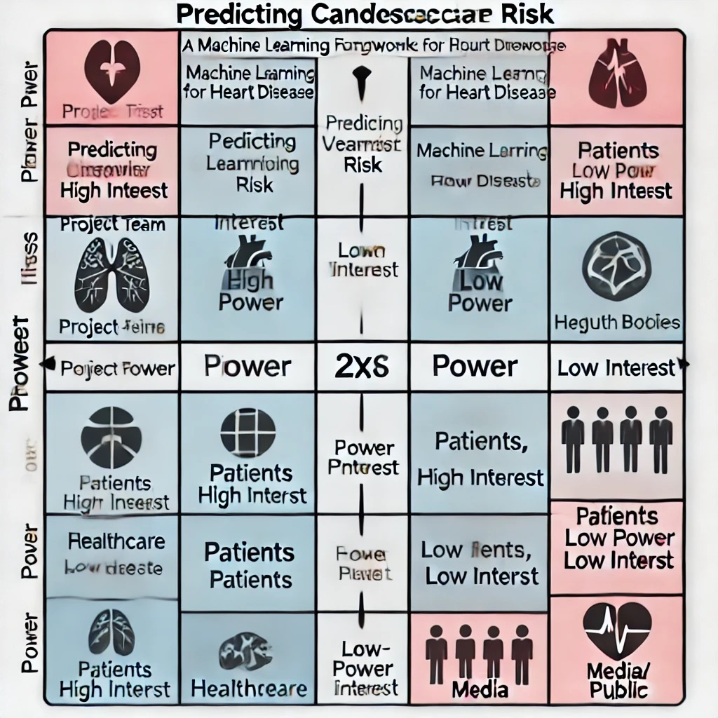

* High Power, High Interest: [Stakeholder Names]
* High Power, Low Interest: [Stakeholder Names]
* Low Power, High Interest: [Stakeholder Names]
* Low Power, Low Interest: [Stakeholder Names]

**7.Empathetic Interviews**

**Conduct Skilled interview with at least 30 citizens/Users by asking open ended questions (What, why/How etc) and list the insights as per the format below**

|  |  |  |
| --- | --- | --- |
| **I need to know**  **(thoughts, feelings, actions)** | **Questions I will ask**  **(open questions)** | **Insights I hope to gain** |
| Thoughts | What are the greatest risk factors for heart disease? | Perceptions in regard to value of technology in healthcare |
|  | What do you think the more prevalent "presence" of technology will do to change how health risk is managed?  Feelings | Concern with the right information and appropriate use. |
|  | How do you perceive the role of your healthcare provider in using this technology? | Knowledge of cardiovascular health and the effect it would have on the patient's psyche. |
| Feelings | How comfortable would you feel with a digital tool that you shared your personal health information with? | Levels of comfort with regard to data sharing/privateness |
|  | What would you be afraid of when receiving a heart disease risk score through a machine learning framework? | Emotions towards predictive health assessment concept |
|  | What would you fear when receiving a risk score for heart disease from a framework using machine learning? | Belief in technology as compared to traditional healthcare practices. |
| Actions | What are some of the things that are in place currently for monitoring or improving your heart health? | Easily getting engaged with a predictive health application. |
|  | If you had been given a risk assessment, then most likely you would either change or react to your health behaviour in the following way, | Preferred source to obtain health information |
|  | If you were found at risk, what changes or responses do you think you might make to your health behavior? | List the barriers to adoption, skepticism, or perhaps lack of understanding. |

**SKILLED INTERVIEW REPORT**

|  |  |  |
| --- | --- | --- |
| **User/Interviewee** | **Questions Asked** | **Insights gained (NOT THEIR ANSWERS)** |
|  | What is the largest risk factors for heart disease? | There is a lack of public knowledge on less common risk factors. |
|  | How do you view your healthcare provider's part when engaging with this technology? | Most patients expect health professionals to be more proactive in embracing technology in their services; however, they are mostly worried about the preparation and knowledge they have of those technologies. |
|  | How comfortable would you feel sharing your personal health information with a digital tool? | How comfortable would you feel sharing your personal health information with a digital tool? |
|  | What would you fear when receiving a heart disease risk score through a machine learning framework? | There are common fears with regards to the accuracy of the risk scores, but also possibly the psychological impact of receiving an adverse assessment |
|  |  |  |

**Key Insights Gained:**

* Insight 1 : There is a massive knowledge gap concerning more rarely discussed risk factors for heart disease and thereby a window of opportunity for enhanced education and communication efforts
* Insight 2 : Users are somewhat uneasy about sharing personal health information with digital tools, primarily out of privacy and data security concerns; therefore, clear data practices are necessary.

**Empathy Map**

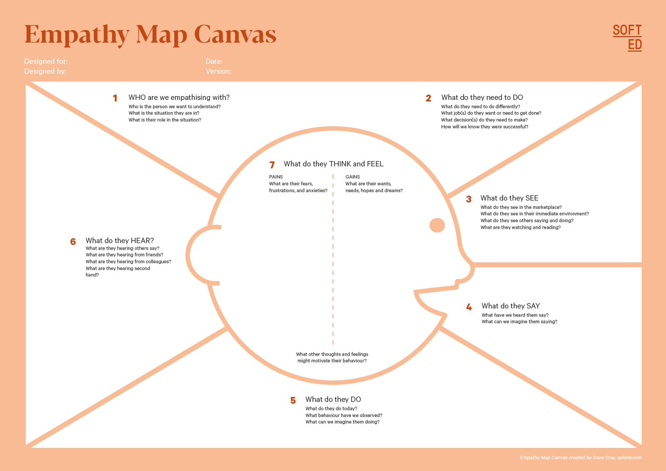

Your Answer:

Your Answer:

Who is your Customer Segment:

Idea/Innovation Title:

Designed By:

Date of Submission:

Your Answer:

Your Answer:

Your Answer:

Your Answer:

Your Answer:

Your Answer:

Your Answer:

1. **Empathy Map**
2. **Who is your Customer?**

**Description: This is where you specify the customer or user you are empathizing with. It could be a specific user persona or a general user segment.**

**Key points:**

* **Define the customer profile clearly (e.g., age, profession, interests).**
* **State their goals and needs related to the innovation or product.**
* **Context in which the user will interact with your solution.**

1. **Who are we empathizing with?**

**Description: This area helps you define who the user is, what their situation looks like, and what role they play. It emphasizes understanding the user’s perspective in depth.**

**Key points:**

* **Define the user's characteristics (e.g., personality, values, and responsibilities).**
* **State the user's goals and challenges in their environment.**
* **What is the user's broader situation (professionally or personally)?**

1. **What do they need to DO?**

**Description: This section identifies what actions or tasks the user needs to perform. It helps highlight the expectations and demands the user faces.**

**Key points:**

* **Clarify the tasks or actions the user needs to complete.**
* **What decisions do they need to make?**
* **How do they define success or failure in their tasks?**

1. **What do they SEE?**

**Description: This focuses on the visual stimuli or environment that the user interacts with. It's important to consider what users see in their immediate surroundings and in their larger world.**

**Key points:**

* **What do users see in their physical and digital environment?**
* **What trends or competitors do they notice?**
* **How do these visual elements influence their behavior?**

1. **What do they SAY?**

**Description: This section captures what the user might say in public, such as comments or feedback they give in conversations or on social media.**

**Key points:**

* **What might users express openly in conversation about their problems?**
* **How do they express their goals or frustrations?**
* **What are their words during customer interviews or feedback?**

1. **What do they DO?**

**Description: This section focuses on what the user does, the actual behaviors they exhibit, and actions they take in different situations.**

**Key points:**

* **What observable actions do users take?**
* **What habits or routines do they follow?**
* **What might users do to try and solve their problems?**

1. **What do they HEAR?**

**Description: This addresses what information the user receives from external sources, such as colleagues, media, or industry trends. It helps map the influences surrounding the user.**

**Key points:**

* **What are they hearing from peers, mentors, or the industry?**
* **What media or channels of information are they exposed to?**
* **Are there any strong influencers guiding their behavior?**

1. **What do they THINK and FEEL?**

**Description: This is one of the most insightful sections, addressing the internal emotions, concerns, and motivations of the user. It helps identify their deep-rooted feelings.**

**Key points:**

* **What are their fears, worries, and anxieties?**
* **What are their motivations and desires?**
* **How do their thoughts and feelings align with their actions?**

1. **Pains and Gains**

**Description: This section focuses on the user’s frustrations and their desired outcomes. It helps to frame the user’s challenges (pains) and the benefits they seek (gains).**

**Key points:**

* **What are the user’s main pain points?**
* **What would make their life easier or more fulfilling?**
* **What benefits do they hope to achieve from your product or solution?**

**8. Persona of Stakeholders**

**Stakeholder Name:**

**Demographics: Key characteristics of your target audience, such as age, gender, income, and location.**

**Goals: What the stakeholders or customers want to achieve in relation to the innovation.**

**Challenges: The obstacles or difficulties faced by stakeholders that the innovation aims to address.**

**Aspiration: The long-term desires or dreams of your target audience related to the innovation.**

**Needs: The essential requirements of your customers or stakeholders that must be met.**

**Pain Points: Specific problems or frustrations experienced by the target audience.**

**Storytelling: A narrative that highlights the journey of the stakeholder or customer, illustrating the problem and how the innovation can solve it.**

**Sample:**

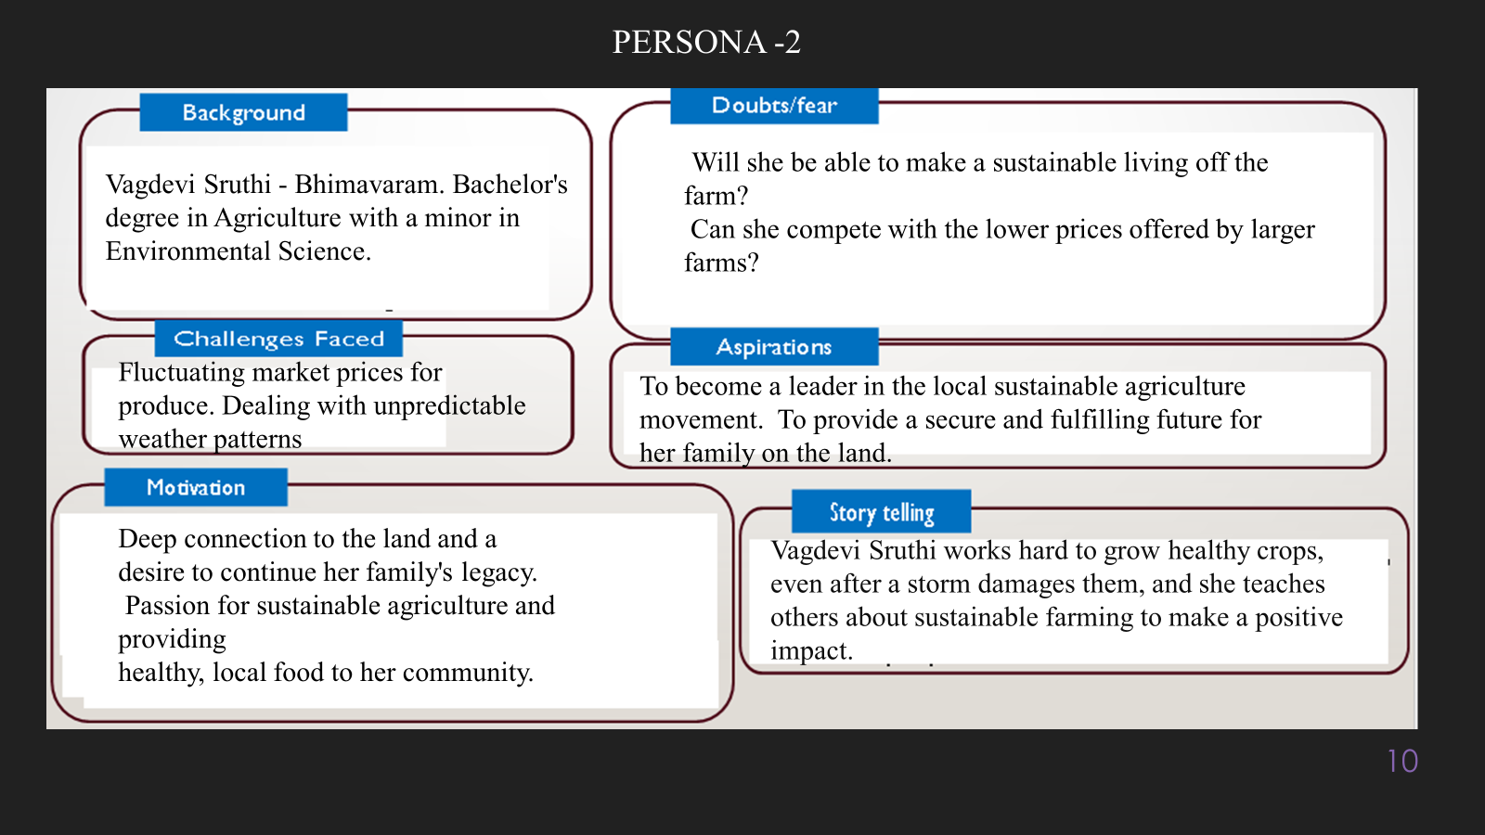

**10. Look for Common Themes, Behaviors, Needs, and Pain Points among the Users**

Analyse the data from your affinity diagram to uncover recurring patterns among your users, helping you better understand their expectations and challenges.

**Common Themes: Identify broad ideas or issues that repeatedly appear across different groups in your affinity diagram.**

**Common Behaviors: Observe how users consistently act or respond in relation to the problem or product throughout their journey.**

**Common Needs: Pinpoint essential requirements or desires that many users share, highlighting what they need for a better experience.**

**Common Pain Points: Look for frustrations or obstacles that frequently hinder the user experience, which your project can address.**

**12. Define Needs and Insights of Your Users**

**User Needs: Define the core requirements your users have in relation to the problem or product. These could be functional, emotional, or societal needs that your solution must address.**

**User Insights: Summarize the key understandings or observations you've uncovered about your users' behaviors, motivations, and pain points. These insights provide a deeper understanding of why users behave the way they do and what drives their decisions.**

**13. POV Statements**

**POV Statements:**

* [User] needs a way to [need] because [insight].

|  |  |  |  |
| --- | --- | --- | --- |
| PoV Statements  (At least ten) | Role-based or Situation-Based | Benefit, Way to Benefit,  Job TBD,  Need (more/less) | PoV Questions  (At least one per statement) |
| (Erase this example) When I drive to work, I want to avoid traffic jams so I don’t get in trouble with my boss for being late. | Situation | Way to Benefit | What can we design that will enable drivers to avoid traffic jams?  What can we design that will enable workers to avoid getting in trouble for being late to work? |
|  |  |  |  |
|  |  |  |  |
|  |  |  |  |
|  |  |  |  |

**14. Develop POV/How Might We (HMW) Questions to Transform Insights/Needs into Opportunities for Design**

Turn your user needs and insights into actionable opportunities by framing them as "How Might We" (HMW) questions. These questions will spark creative problem-solving and guide your innovation process.

1. **How Might We: Based on the needs and insights you've identified, create open-ended questions starting with "How might we...?" These questions should aim to solve user pain points, enhance the experience, or address specific needs.**

**Examples:**

* **User Need: "Users need a quicker way to access customer support."**
  + **HMW Question: "How might we create a more efficient and accessible customer support system?"**
* **Insight: "Users feel overwhelmed by too many options."**
  + **HMW Question: "How might we simplify decision-making for our users?"**

**Task:**

**Write 3-5 "How Might We" questions based on your analysis of user needs and insights. These questions should challenge you to think of innovative solutions that can address user problems in meaningful ways.**

**This task encourages participants to think creatively about solving user problems, transforming challenges into opportunities for innovation.**

|  |  |
| --- | --- |
| User Need/Insight | "How Might We" Question |
| [State the user need or insight clearly] | **How might we... [formulate an open-ended question to address the need or insight]?** |

**16. Crafting a Balanced and Actionable Design Challenge**

The Design Challenge Should Neither Be Too Narrow Nor Too Broad and It Should Be an Actionable Statement with a quantifiable goal. It should be a culmination of the POV questions developed.

**Design Challenge:** [Actionable Statement]

**17. Validating the Problem Statement with Stakeholders for Alignment**

Ensure your problem statement accurately represents the needs and concerns of your stakeholders and users. This involves gathering feedback from these groups to confirm that the problem is relevant and significant from their perspective. By validating early, you can refine the problem statement to better align with real-world challenges, ensuring your solution addresses the correct issues.

**Validation Plan:**

**Stakeholder/User Feedback (Min. 10 Stakeholders/Experts):**

|  |  |  |  |
| --- | --- | --- | --- |
| Stakeholder/User | Role | Feedback on Problem Statement | Suggestions for Improvement |
| [Name/Group] | **[Role/Title]** | **[Does the problem resonate with them? Why or why not?]** | **[Suggestions for refining the problem statement]** |
| [Name/Group] | **[Role/Title]** | **[Does the problem resonate with them? Why or why not?]** | **[Suggestions for refining the problem statement]** |

**18. Ideation**

**Ideation Process:**

|  |  |  |  |
| --- | --- | --- | --- |
| Idea Number | Proposed Solution | Key Features/Benefits | Challenges/Concerns |
| Idea 1 | **[Brief description of solution]** | **[What are the key benefits of this solution?]** | **[What challenges or concerns exist?]** |
| Idea 2 | **[Brief description of solution]** | **[What are the key benefits of this solution?]** | **[What challenges or concerns exist?]** |
| Idea 3 | **[Brief description of solution]** | **[What are the key benefits of this solution?]** | **[What challenges or concerns exist?]** |
| Idea 4 | **[Brief description of solution]** | **[What are the key benefits of this solution?]** | **[What challenges or concerns exist?]** |
| Idea 5 | **[Brief description of solution]** | **[What are the key benefits of this solution?]** | **[What challenges or concerns exist?]** |

**18. Idea Evaluation**

Evaluate the Idea based on 10/100/1000 grams

|  |  |  |  |  |
| --- | --- | --- | --- | --- |
| Idea | Impact (10/100/1000 grams) | Feasibility (10/100/1000 grams) | Alignment (10/100/1000 grams) | Total Weight |
| Idea 1 | **[Assign weight]** | **[Assign weight]** | **[Assign weight]** | **[Sum of weights]** |
| Idea 2 | **[Assign weight]** | **[Assign weight]** | **[Assign weight]** | **[Sum of weights]** |
| Idea 3 | **[Assign weight]** | **[Assign weight]** | **[Assign weight]** | **[Sum of weights]** |
| Idea 4 | **[Assign weight]** | **[Assign weight]** | **[Assign weight]** | **[Sum of weights]** |
| Idea 5 | **[Assign weight]** | **[Assign weight]** | **[Assign weight]** | **[Sum of weights]** |

**Example:**

|  |  |  |  |  |
| --- | --- | --- | --- | --- |
| Idea | Impact (10/100/1000 grams) | Feasibility (10/100/1000 grams) | Alignment (10/100/1000 grams) | Total Weight |
| Idea 1 | **1000** | **100** | **1000** | **2100** |
| Idea 2 | **100** | **1000** | **100** | **1200** |
| Idea 3 | **100** | **100** | **100** | **300** |

Further, use solution concept form to scrutinize the idea

**Solution Concept Form**

**1. Problem Statement:**

* **[State the validated problem your solution addresses.]**

**2. Target Audience:**

* **[Describe the main users or customers who will benefit from this solution.]**

**3. Solution Overview:**

* **[Provide a brief description of the solution concept.]**

**4. Key Features:**

| **Feature** | **Description** |
| --- | --- |
| **Feature 1** | **[Briefly describe the main feature of your solution]** |
| **Feature 2** | **[Briefly describe another key feature]** |
| **Feature 3** | **[Briefly describe a third key feature]** |

**5. Benefits:**

| **Benefit** | **Description** |
| --- | --- |
| **Benefit 1** | **[What value does this solution bring?]** |
| **Benefit 2** | **[How does this solution solve the problem?]** |
| **Benefit 3** | **[What makes this solution stand out?]** |

**6. Unique Value Proposition (UVP):**

* **[Summarize why this solution is unique and why it will appeal to your target audience.]**

**7. Key Metrics:**

| **Metric** | **Measurement** |
| --- | --- |
| **Metric 1** | **[What is the key metric to measure success?]** |
| **Metric 2** | **[What is another key metric for tracking progress?]** |

**8. Feasibility Assessment:**

* **[Provide a brief evaluation of how achievable or practical this solution is (consider resources, time, and technology).]**

**9. Next Steps:**

* **[Outline the next steps for further developing or prototyping this solution.]**